Technogym Run / Excite Treadmill
Commercial-grade cardio equipment
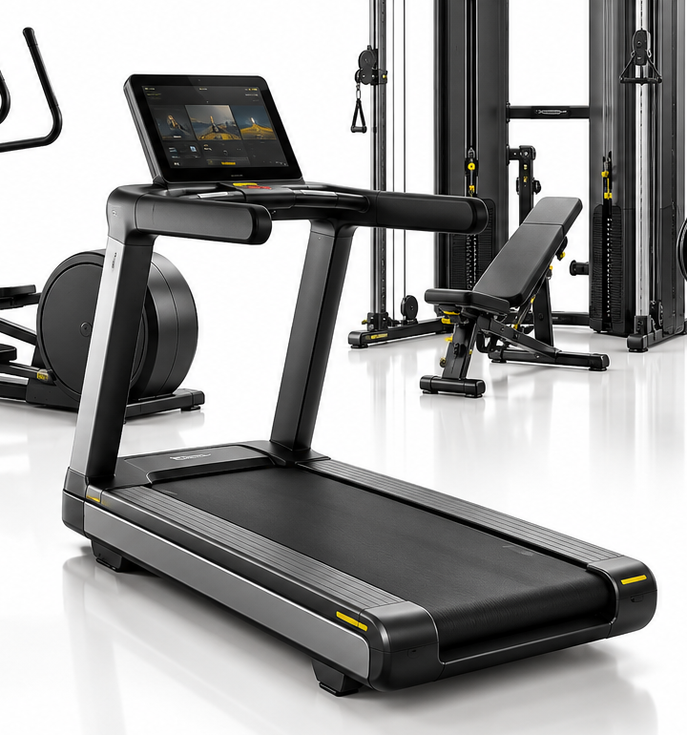
Description
Professional Technogym treadmill designed for high-use commercial fitness environments. The Excite family includes connected cardio equipment with Technogym Live interfaces, while the newer Technogym Run adds a broader combination of cardio and strength-oriented training modes.
Technical data
Equipment type | Commercial treadmill / cardio
Typical range | Run Excite / Excite Live / Run family
Console | Model-dependent; LED, touch or Technogym Live configurations
Connectivity | Model-dependent; Wi‑Fi / Bluetooth / NFC / wearable integration on connected versions
Maximum user weight | Model-dependent — verify against exact machine
Dimensions | Model/year dependent — verify before purchase
Equipment weight | Model/year dependent — verify before transport
Electrical supply | Model/version dependent
Key features
• Heavy-duty running deck and commercial frame
• Fast-access controls on equipped versions
• Connected training and multimedia options on Excite Live models
• Suitable for gyms, hotels, clubs and wellness centres
• Important refurbishment checks: belt, deck, rollers, motor, inverter, display and safety systems
Technical note: specifications vary substantially by model, console and production year; confirm the serial-number specification before quoting a machine.
Technogym Excite Bike
Professional upright exercise bike
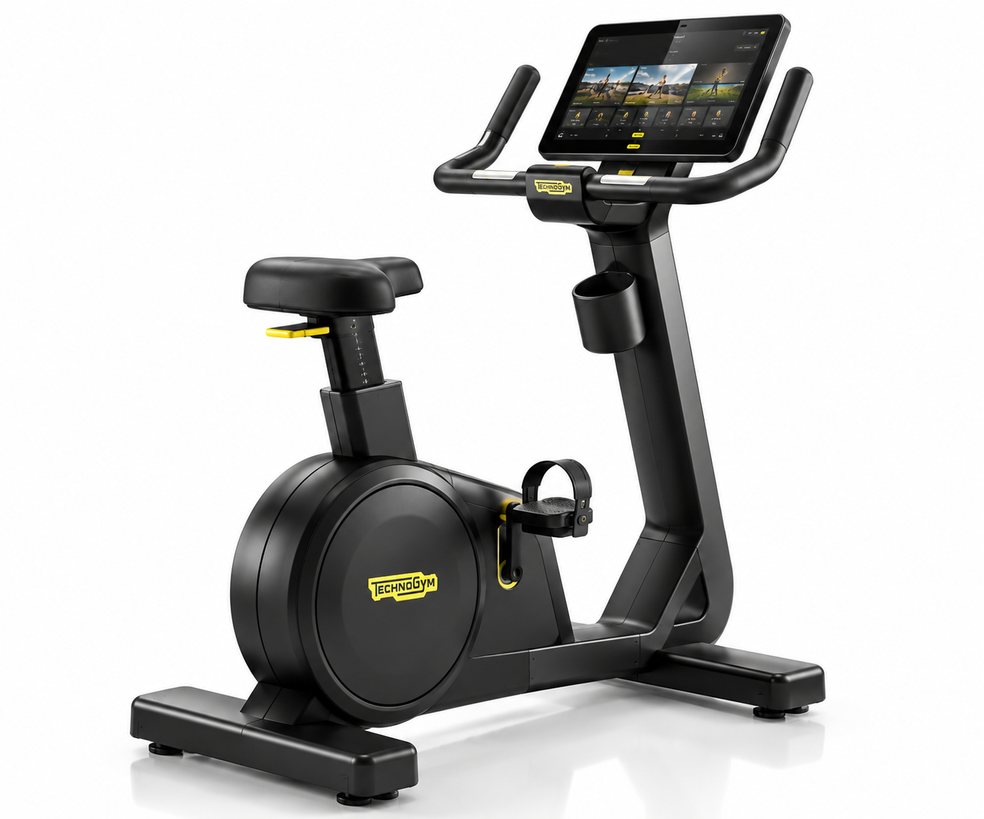
Description
Professional upright bike from the Technogym Excite family, designed for commercial cardio areas. The illustrated machine represents the connected touchscreen configuration commonly found in premium fitness facilities.
Technical data
Equipment type | Commercial upright exercise bike
Representative model | Excite / Bike 500i family
Console | Touchscreen / connected configuration shown
Heart-rate monitoring | Hand sensors; telemetry/Bluetooth on supported versions
Connectivity | Model-dependent
Dimensions | Model/version dependent
Equipment weight | Model/version dependent
Resistance | Electronic resistance; model dependent
Key features
• Adjustable saddle and ergonomic handlebars
• Large touchscreen console on connected versions
• Heart-rate monitoring options
• Commercial frame designed for repeated daily use
• Refurbishment checks: drive system, bearings, pedals, saddle, electronics and console
Reference: Technogym technical documentation for Bike 500i SP identifies the Excite bike family and its component architecture; exact dimensions/specification should be confirmed by model and serial number.
Technogym Synchro / Excite Elliptical
Commercial cross-training equipment
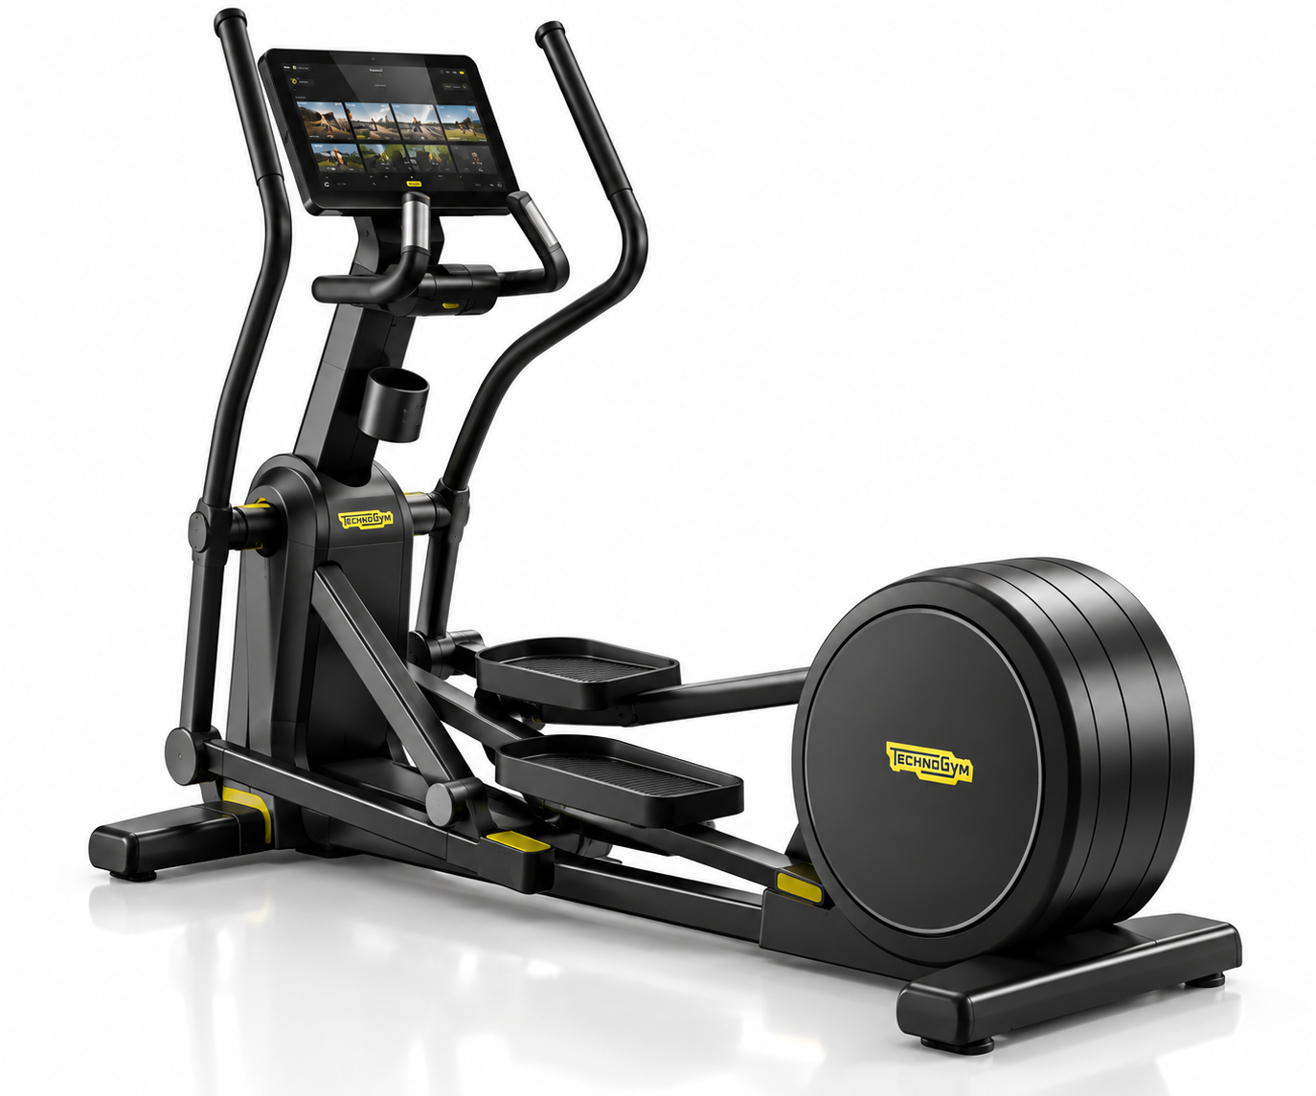
Description
Commercial elliptical cross trainer designed for full-body cardio training. The Excite family includes Synchro models with connected console options and configurations for intensive fitness-centre use.
Technical data
Equipment type | Commercial elliptical / cross trainer
Representative range | Excite Synchro
Representative dimensions | 2,180 × 700 × 1,685 mm (Synchro 500 Live reference)
Representative equipment weight | 152 kg (Synchro 500 Live reference)
Maximum user weight | 180 kg (Synchro 500 Live reference)
Max resistance | Up to 600 W at 160 rpm (Synchro 500 Live reference)
Console | Technogym Live 10-inch on referenced Live version
Connectivity | Wi‑Fi; Bluetooth and additional connectivity on selected versions
Key features
• Low-impact full-body cardio movement
• Ergonomic upper-body handles
• Integrated touchscreen on Live versions
• Heart-rate monitoring and connected training options
• Refurbishment checks: pedal bearings, joints, drive system, belts, console and resistance system
Source: Technogym Excite Live Synchro technical specification sheet; exact specifications vary by model/version.
Technogym UNICA
Premium multi-function home gym
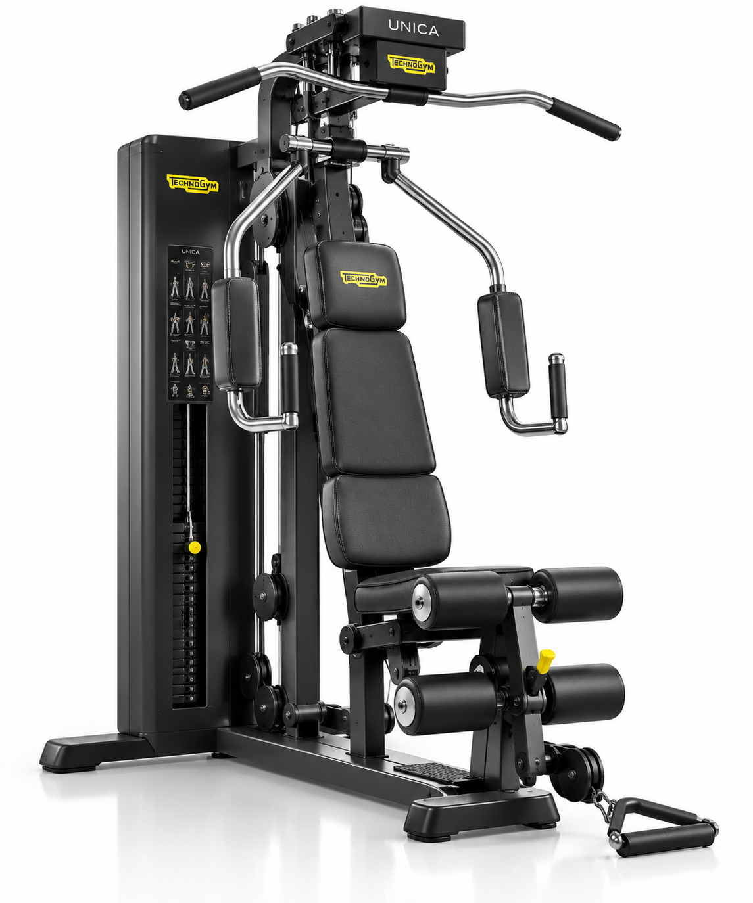
Description
UNICA is Technogym's iconic compact multi-function strength system, designed to provide a wide range of resistance exercises in one integrated machine. Technogym identifies UNICA as an iconic home-wellness product and celebrated its 40th anniversary in 2026.
Technical data
Equipment type | Multi-function strength / home gym
Dimensions | 1,840 × 1,200 × 2,070 mm
Operating footprint | Up to 1,840 × 1,600 × 2,070 mm during operation
Equipment weight | 240 kg
Weight stack | 5–90 kg; 5 kg increments
Power requirement | 110–220 VAC on Trainer version
Integrated functions | Multiple strength exercises, pulleys, press/fly and lower-body work
Key features
• Large range of exercises from one compact station
• Integrated weight stack and cable system
• Adjustable padded seating and exercise positions
• Integrated wheels for positioning
• Refurbishment checks: cables, pulleys, weight stack, upholstery, bearings and adjustment mechanisms
Source: Technogym Personal Line / UNICA technical specification documentation. Specifications can vary by production version.
Technogym Pure Strength Chest Press
Plate-loaded commercial strength machine
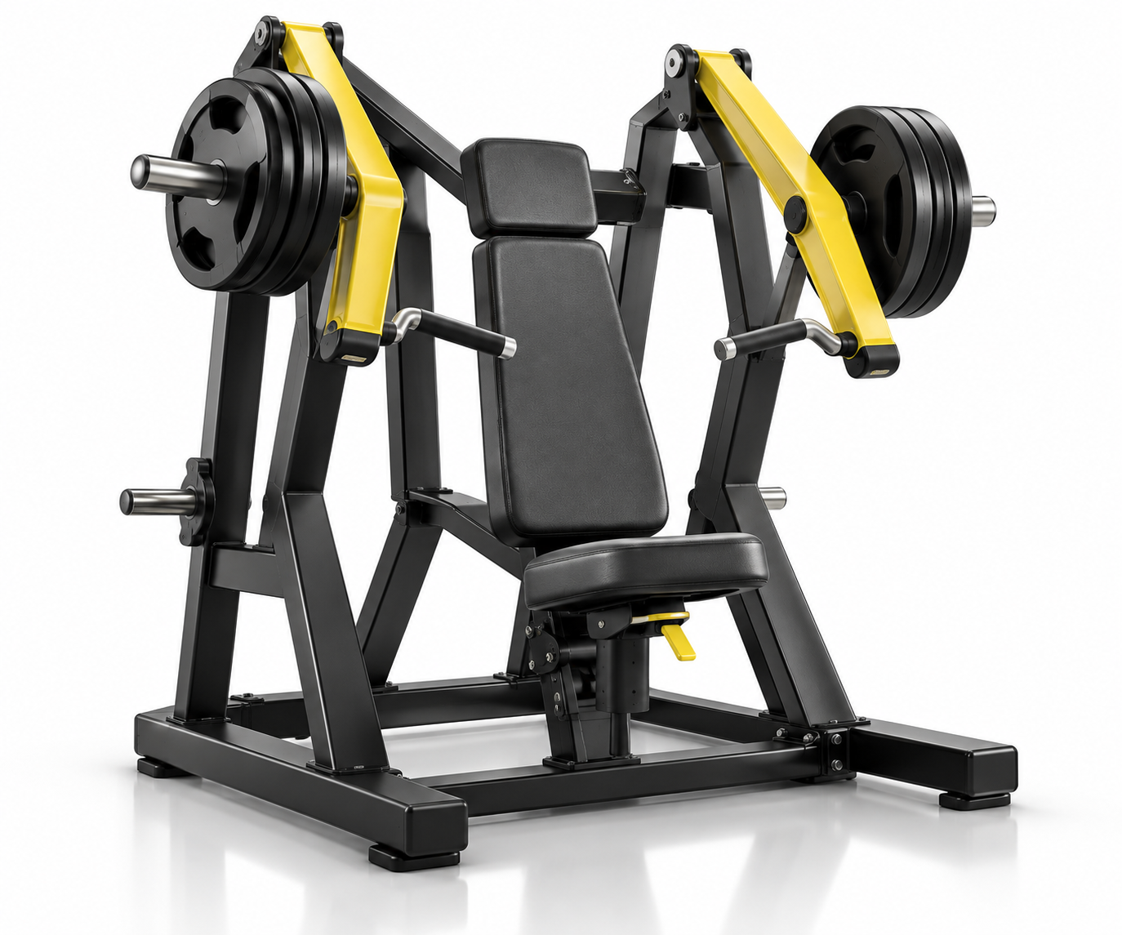
Description
Heavy-duty plate-loaded chest press from the Technogym Pure Strength family. Independent pressing arms allow unilateral or bilateral training, with a converging movement path designed around a natural pressing arc.
Technical data
Equipment type | Commercial plate-loaded chest press
Dimensions | 1,500 × 1,200 × 1,715 mm
Equipment weight | 164 kg
Maximum load | 200 kg
Primary muscles | Pectoralis major, triceps, anterior deltoids
Resistance | Olympic/weight-plate loaded
Arm movement | Independent converging pressing arms
Key features
• Independent left/right pressing arms
• Natural converging movement path
• Heavy-duty commercial steel frame
• Plate-loaded resistance for progressive strength training
• Refurbishment checks: pivots, bearings, handles, upholstery, plate horns and frame finish
Source: Technogym Pure Strength Chest Press specifications; dimensions and weight are published for the 1500 × 1200 × 1715 mm configuration.

